**Submitted by: Submitted to:**

**NAME: Rahul Gusain Hitesh Kumar Sharma**

**SAP: 500084143**

**ROLL NO.: R214220900**

**BATCH: 1 DevOps**

# Build and Release Management

**LAB EXERCISE 3**

**Aim:** Maven Build and usage in other Java Project.

1. **Create a Build of java project using maven.**

**Step 1:-** First we will create a maven project devops.lab3 and add a class, in this class we will write code which performs subtraction and addition.

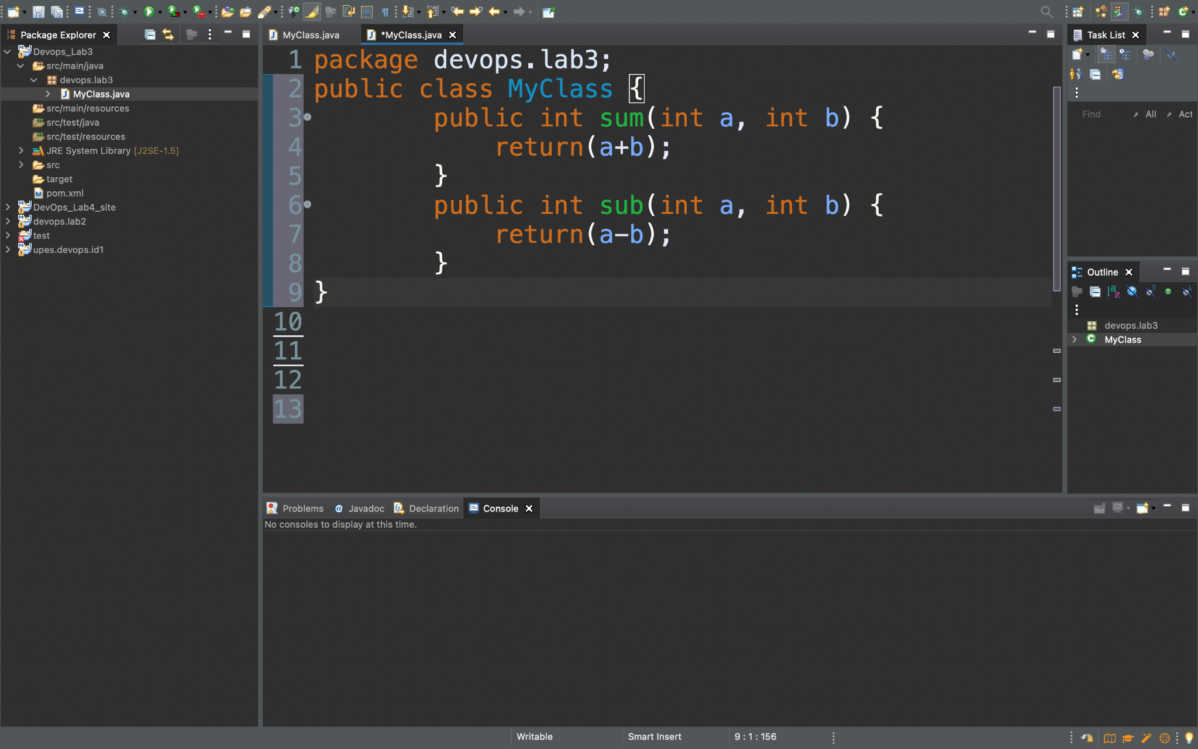

**Step 2:-** Now we will execute Maven build and set the Goal as clean.

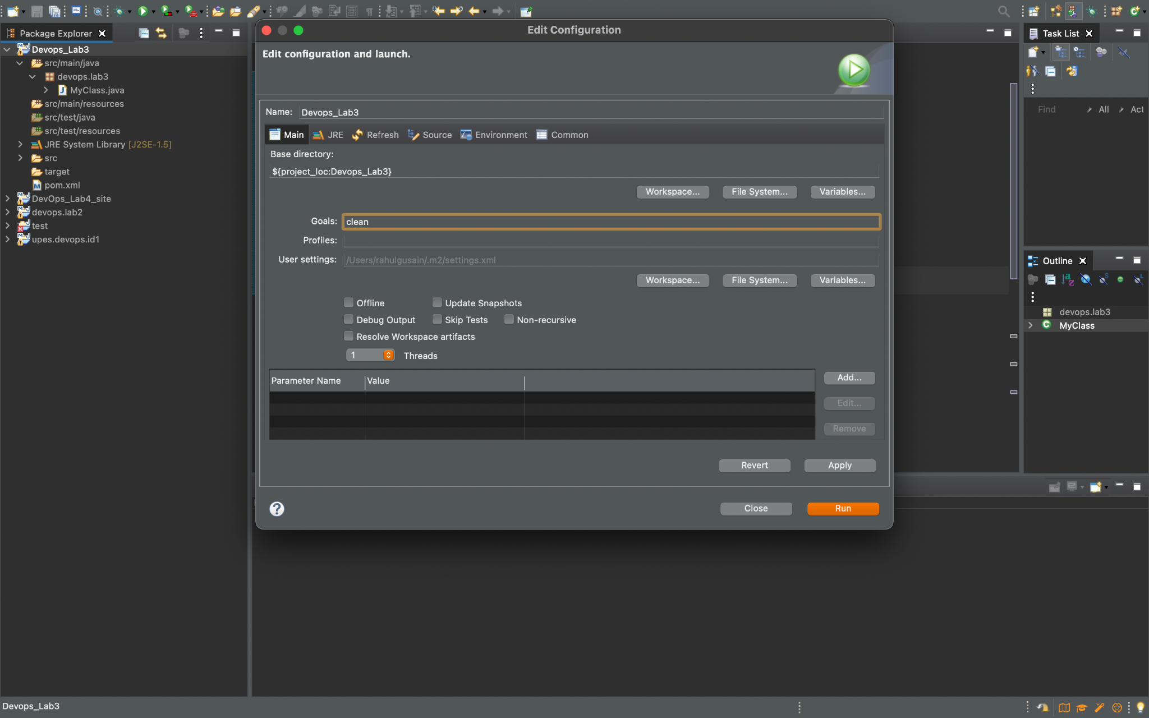

We can see that the build is successful.

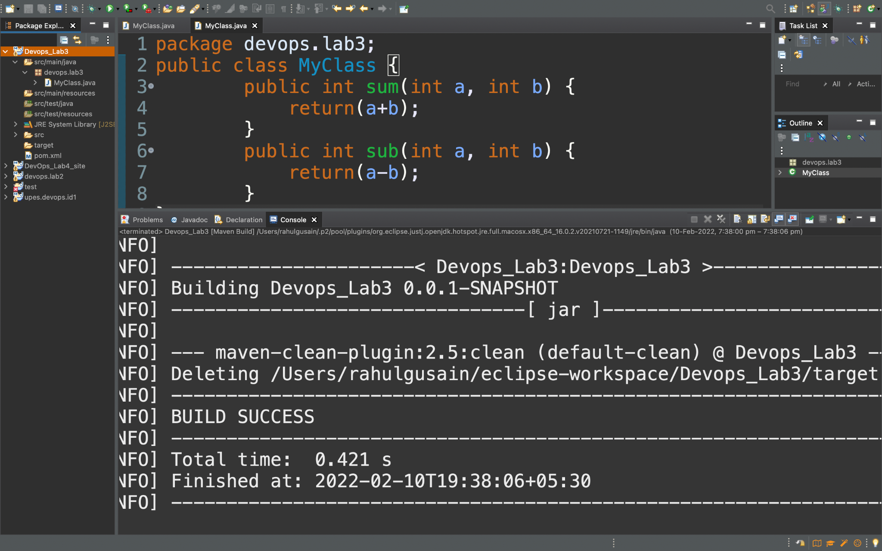

**Step 3 :-** Now we will add Dependency in our pom.xml file to remove the errors which arise during build generation because of using different versions of different tools.

<properties>

<maven.compiler.source>1.8</maven.compiler.source>

<maven.compiler.target>1.8</maven.compiler.target>

</properties>

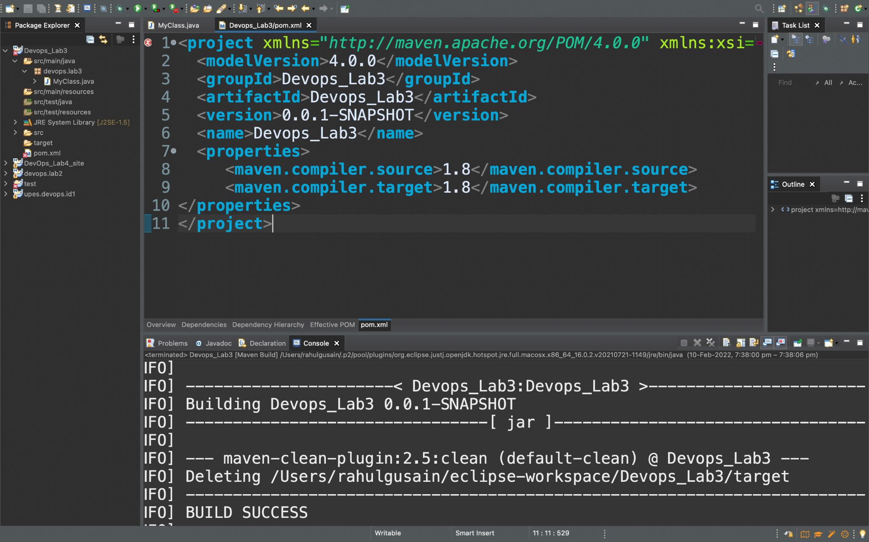

After adding we will set the goal as “install” and again create a build of our project.

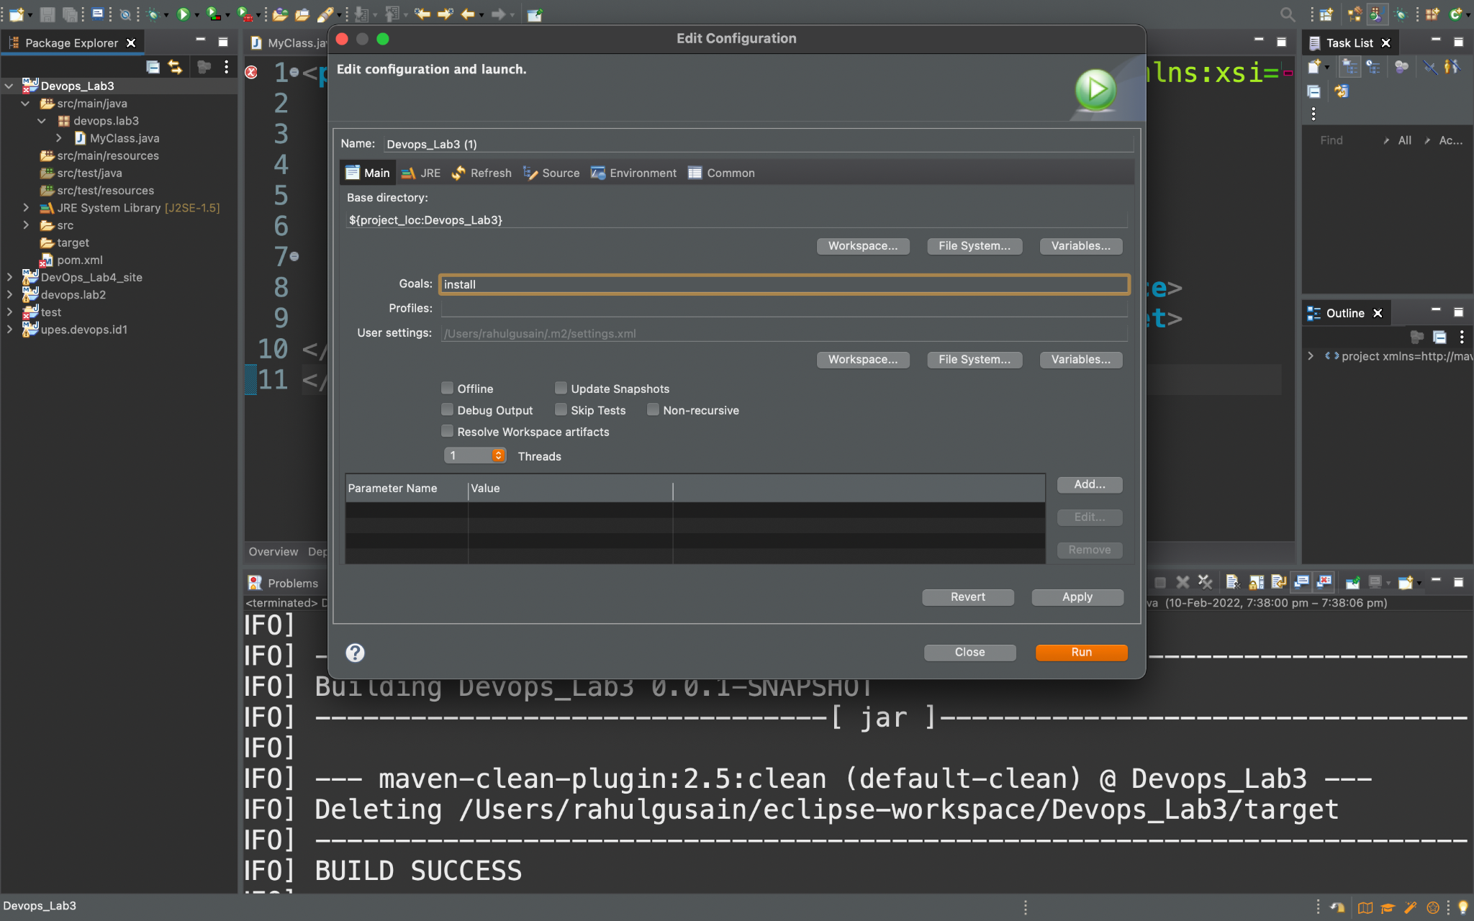

We can see that the build is successful.

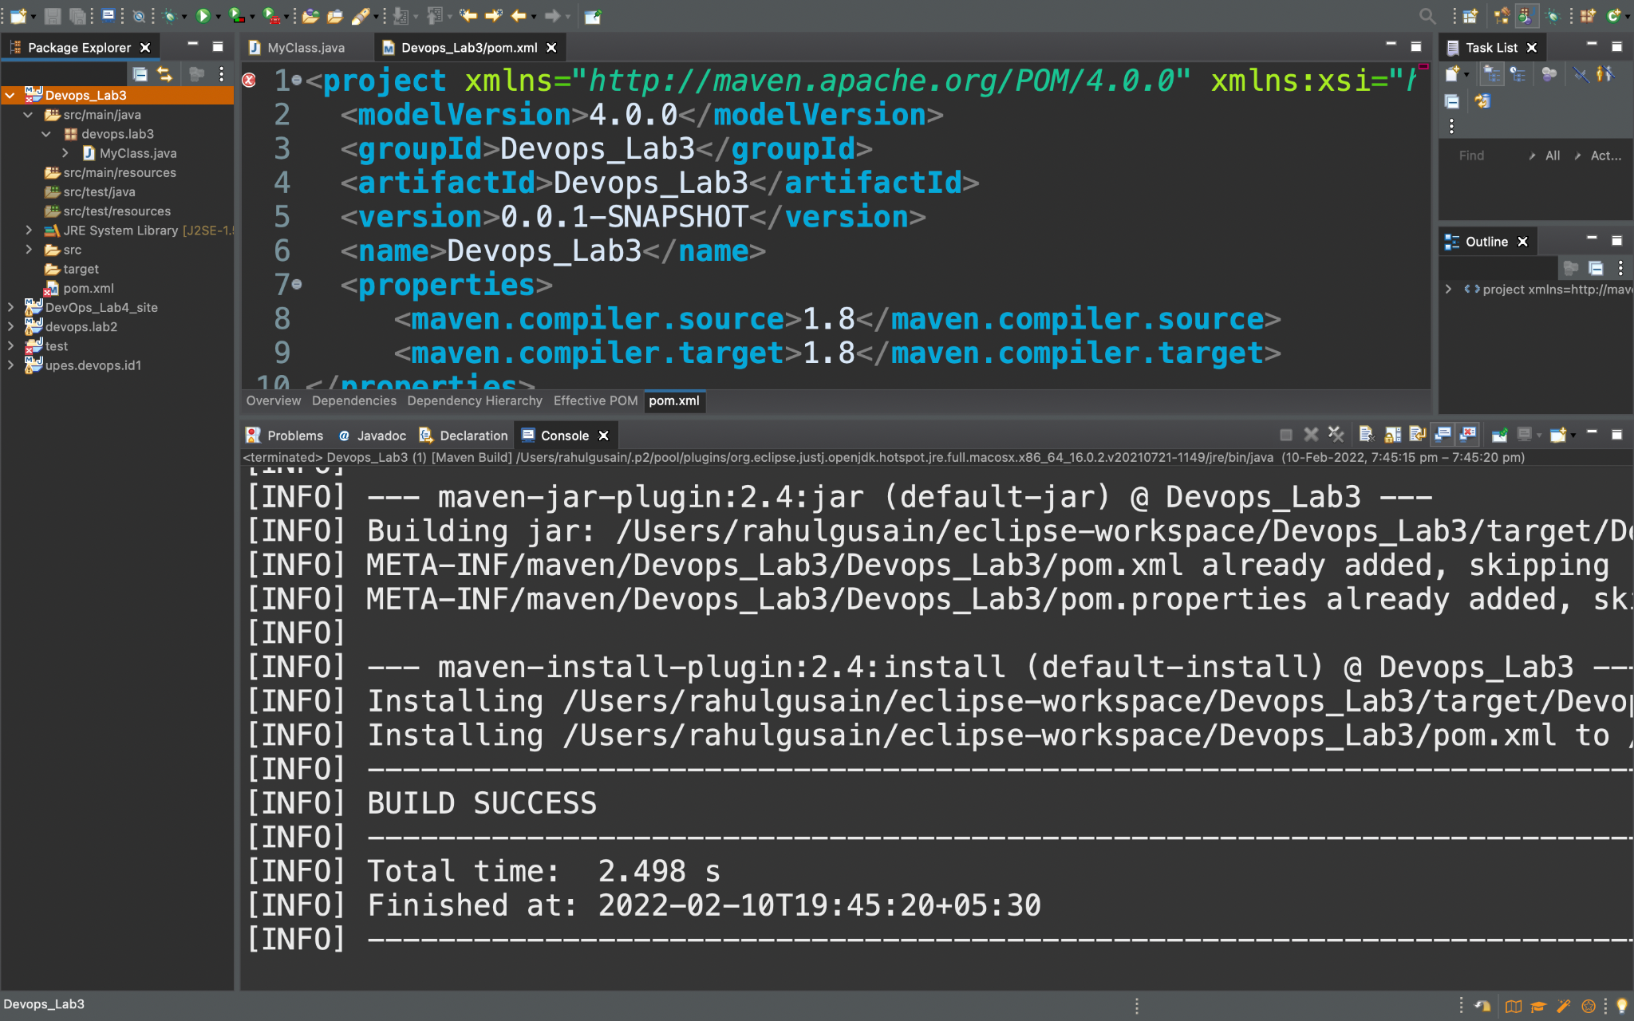

**Step 4 :-** We will create a new java project.

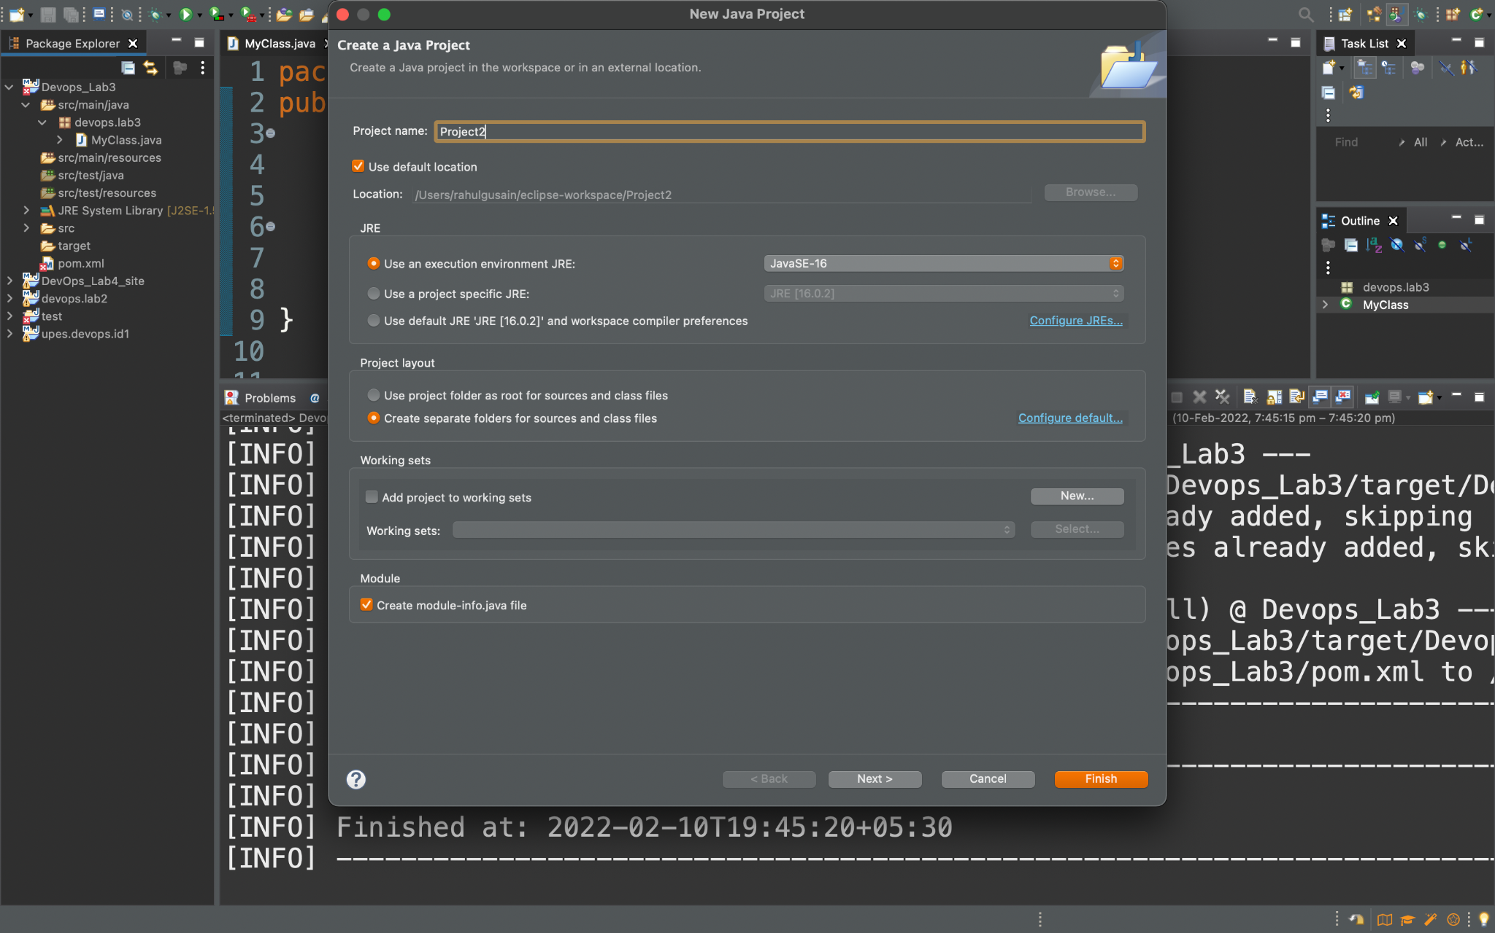

1. **Use that build in some other Java Project.**

**Step 5 :-** In the Java project we will create a package pkg2 and inside that package we will design a class named MyTestClass.

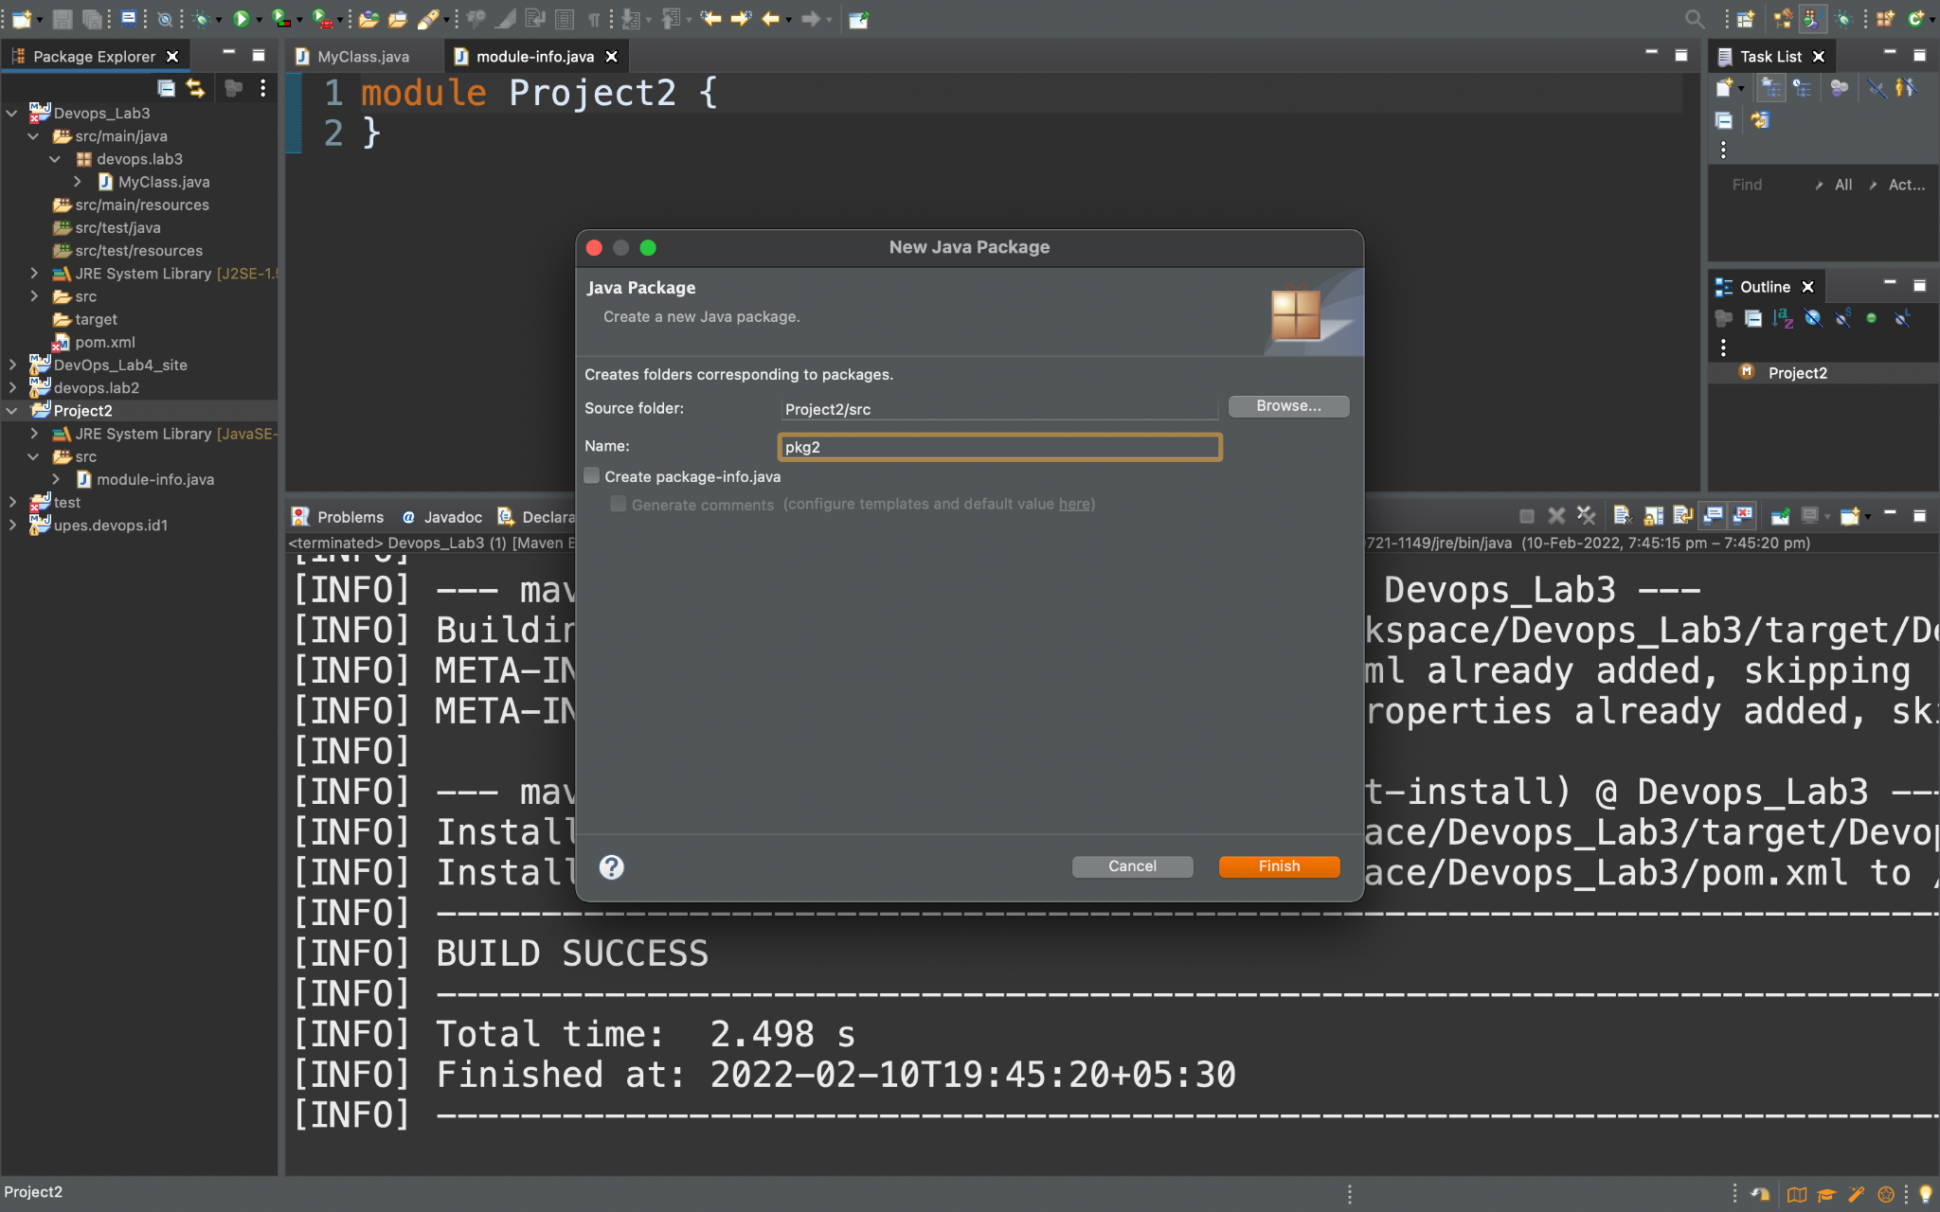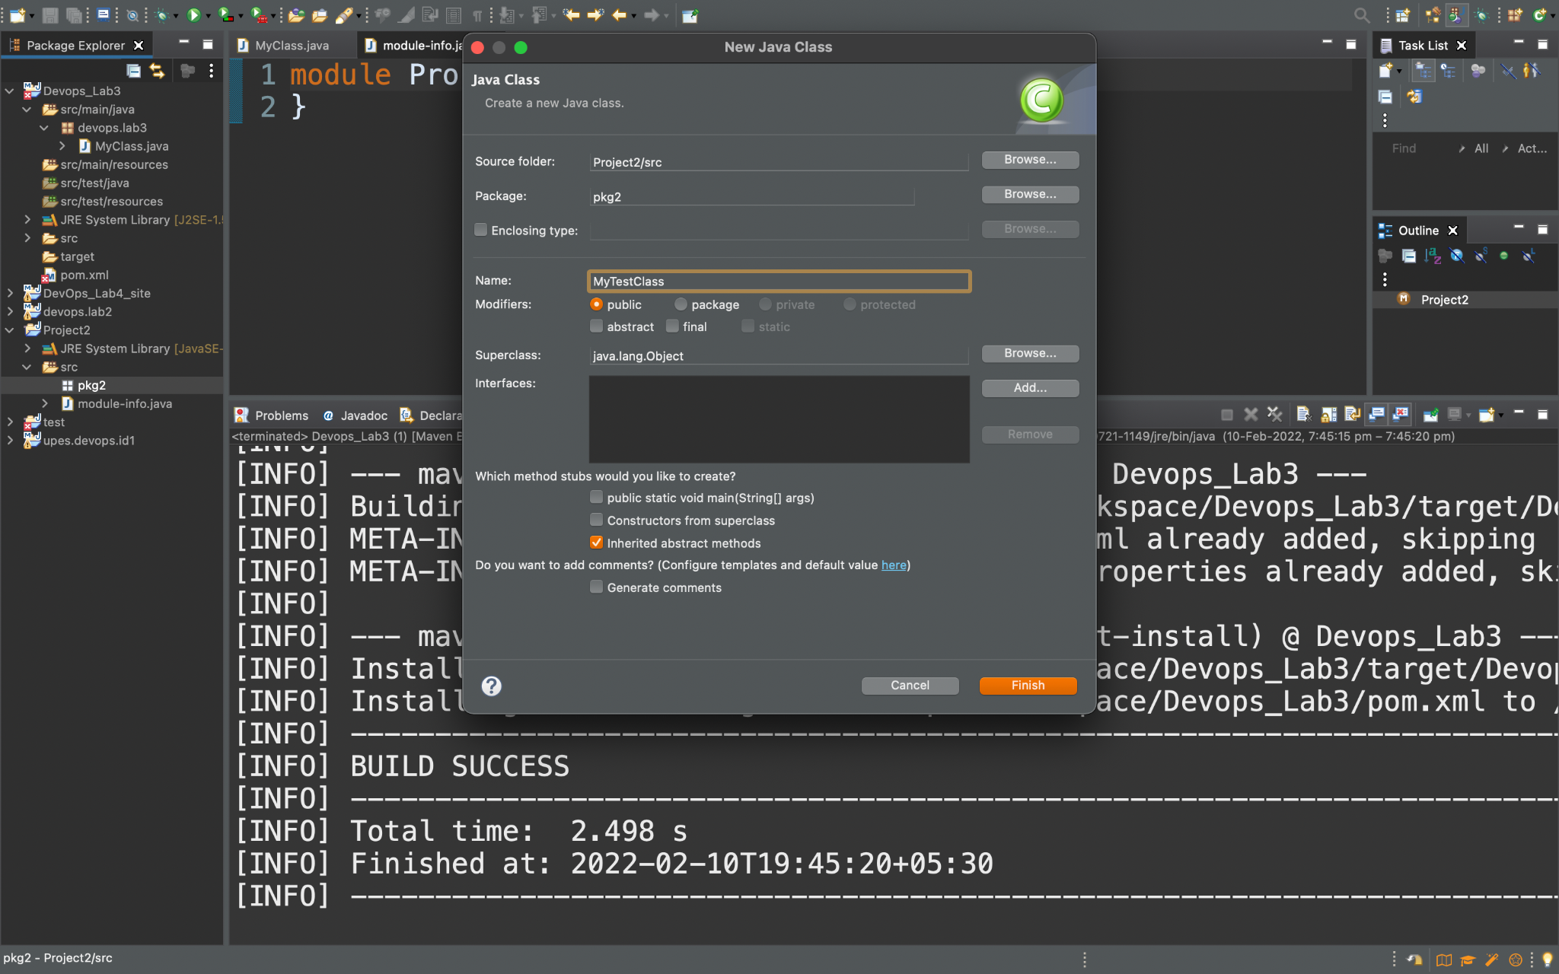

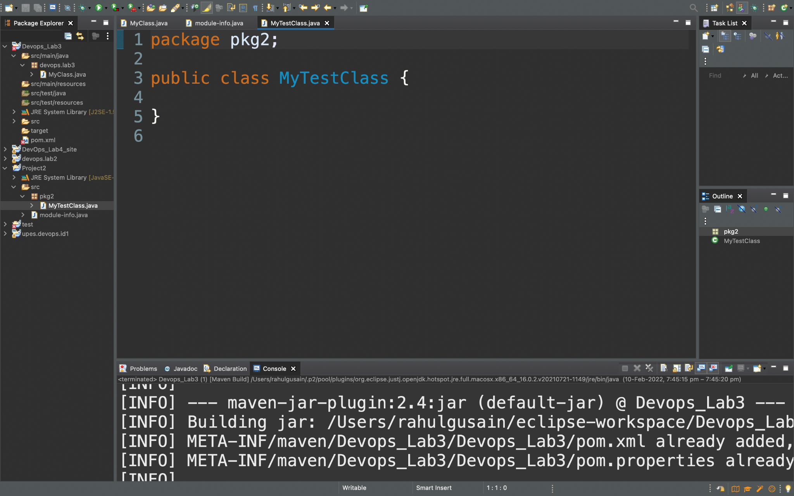

**Step 6:-** Now right-click on java project and Then click on Build Path and then on Configure Build path.

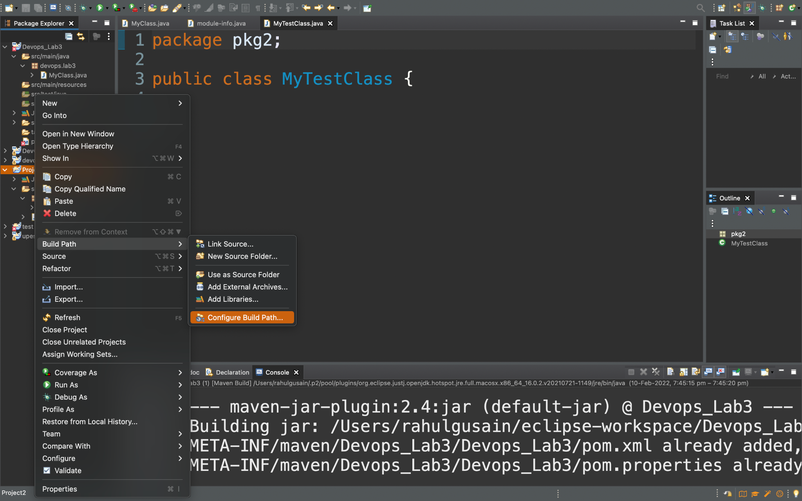

**Step 7:-** Now click on libraries and then on Classpath and then click on Add External JARs.. and click on Apply and Close.

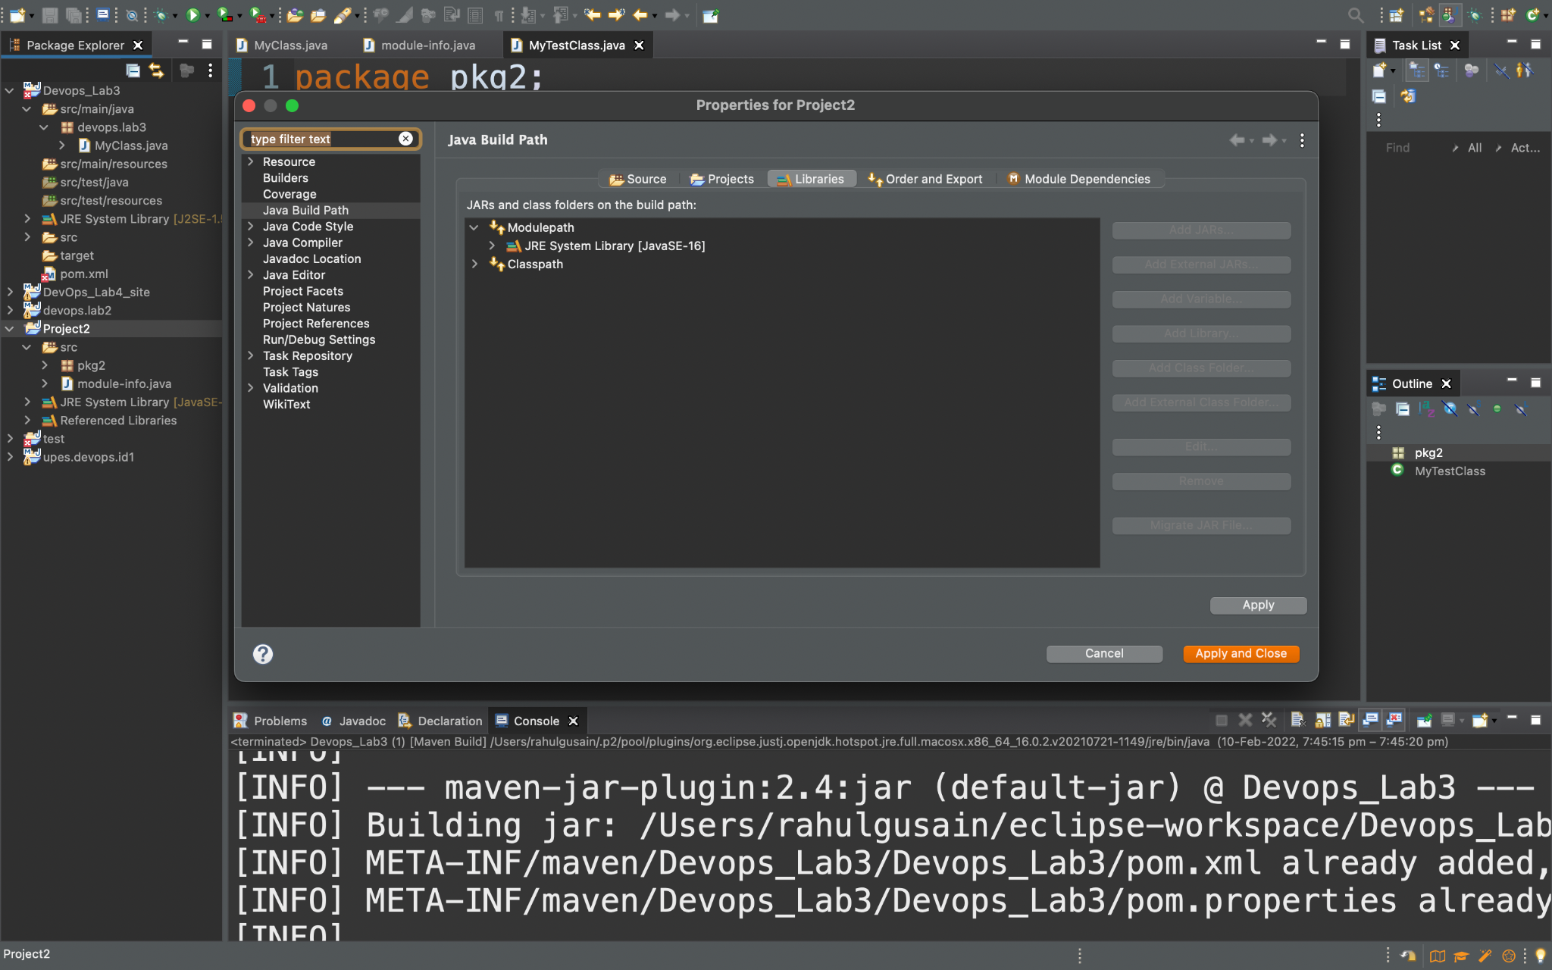

**Step 8:-** Now add the jar file after and open it.

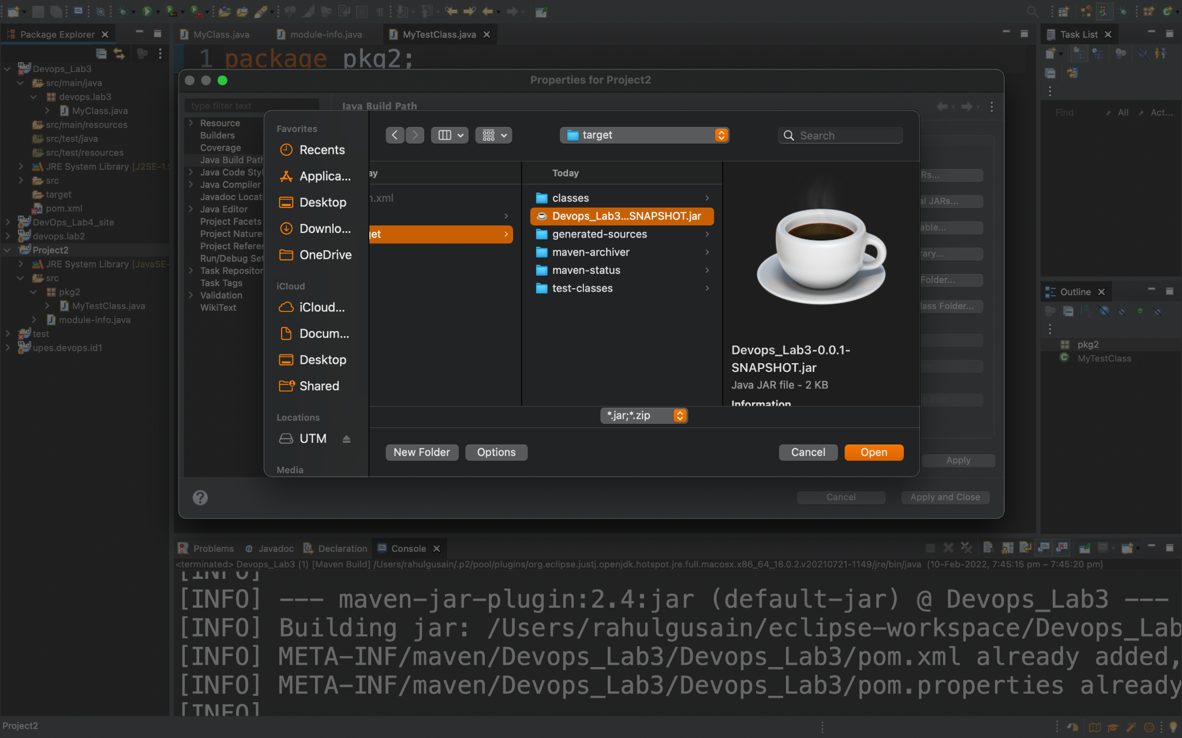

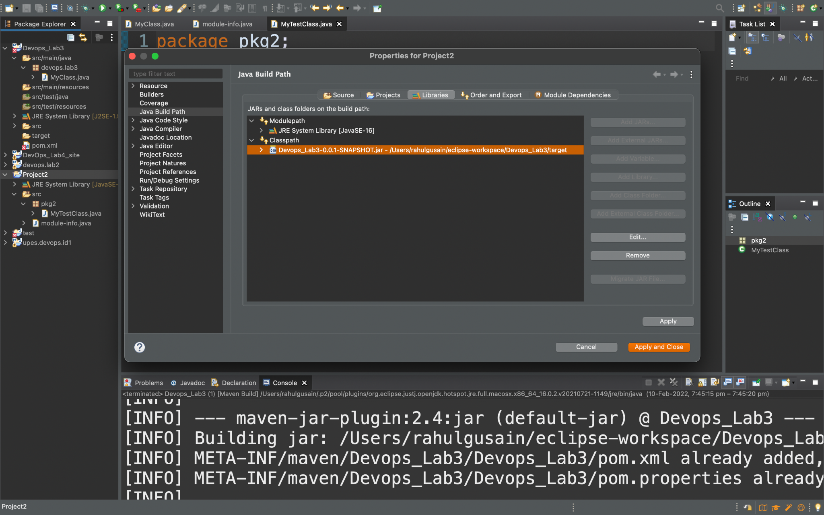

**Step 9:-** We will now delete the class from the maven project and after deleting we will see whether the Class will still give output or not.

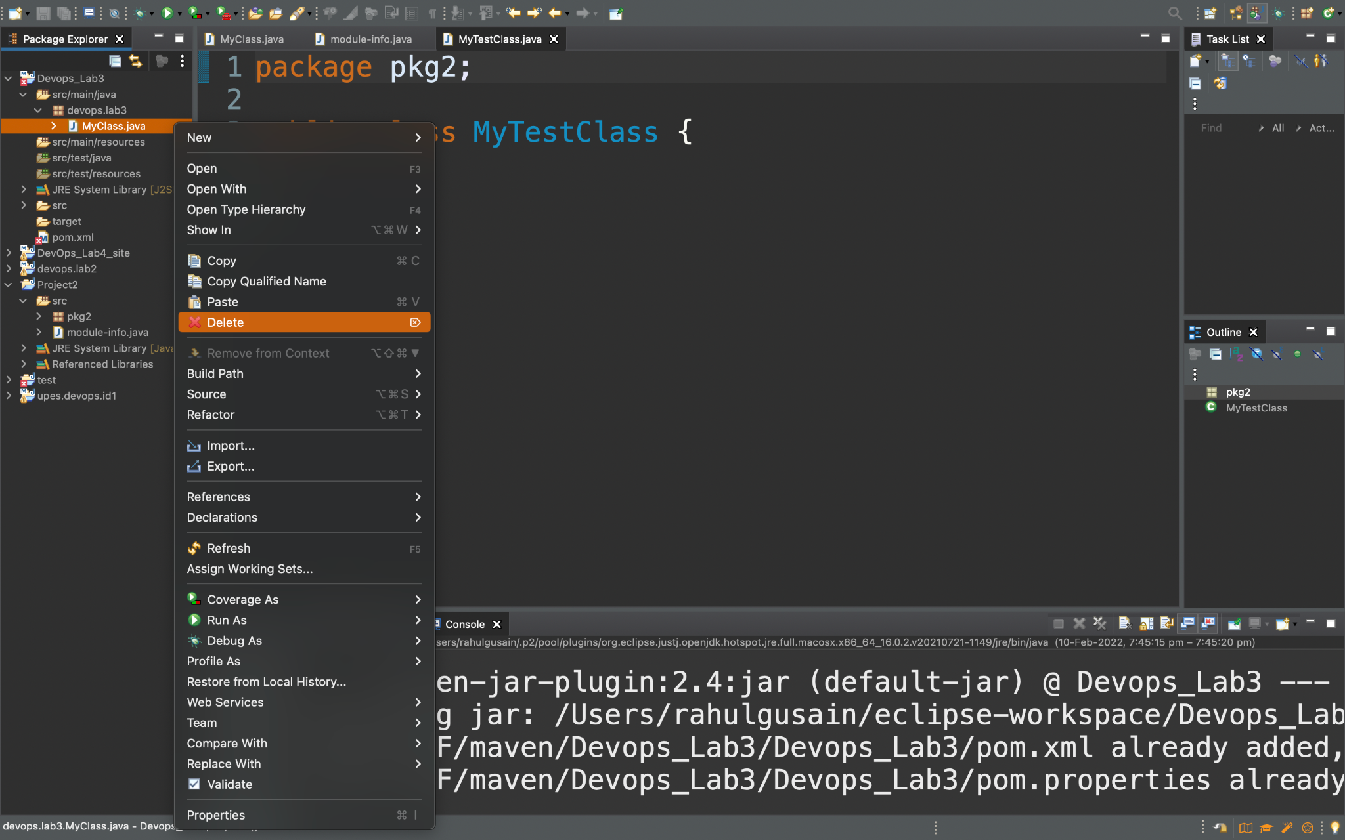

package pkg2;

import devops.lab3.*;

public class MyTestClass {

public static void main();

{

MyClass ob = new MyClass();

System.***out***.println("Sum is -"+ob.sum(6,4));

System.***out***.println("Difference is -"+ob.sub(11,5));

}

}

